Yin Hinton – Design Project 4

December 9, 2020

Program Operation Documentation

Screenshot of the opening of the game no guesses yet

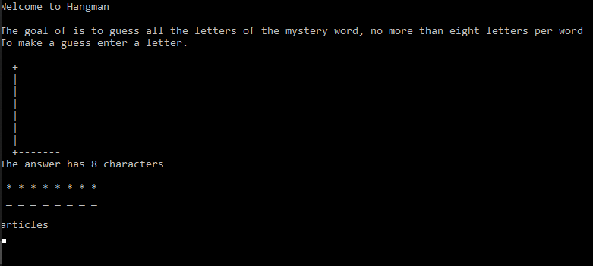

First guess correct,

Error count working properly but something is casing my \* array to bleed into my gallows array

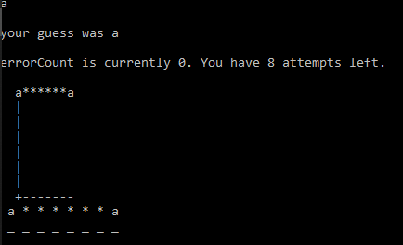

Second guess wrong and the rest will also be wrong for demonstration sake,

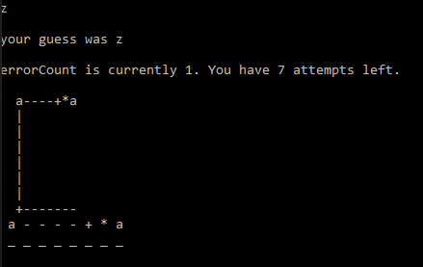

Third guess wrong,

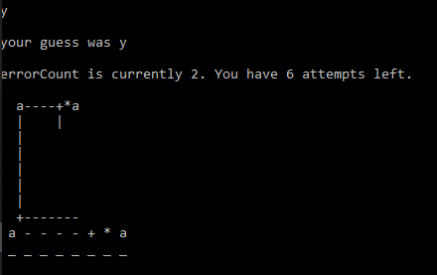

Fourth guess wrong,

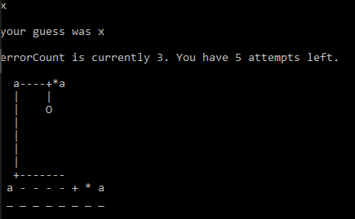

Fifth guess wrong,

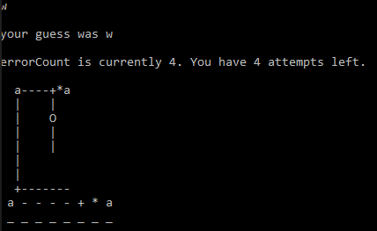

Sixth guess wrong,

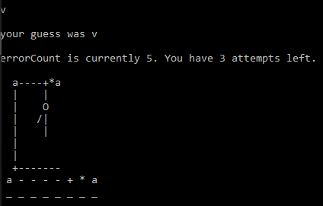

Seventh guess wrong,

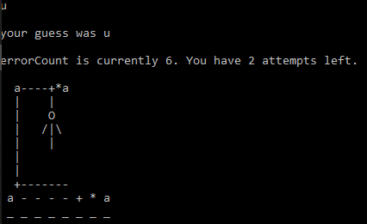

Eighth guess wrong,

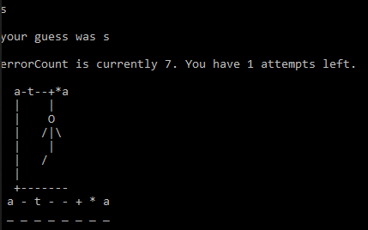

Ninth guess wrong,

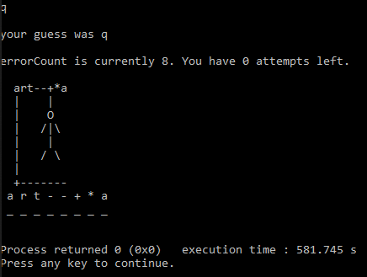

Possible answers list

absolute

argument

articles

banquets

becoming

behavior

birthday

breaking

captions

captures

category

champion

children

clothing

combined

compared

computer

conflict

consider

consumer

covering

creating

creation

customer

daughter

hydrogen

mythical

question

superman

valkyrie